2.4 Prototype
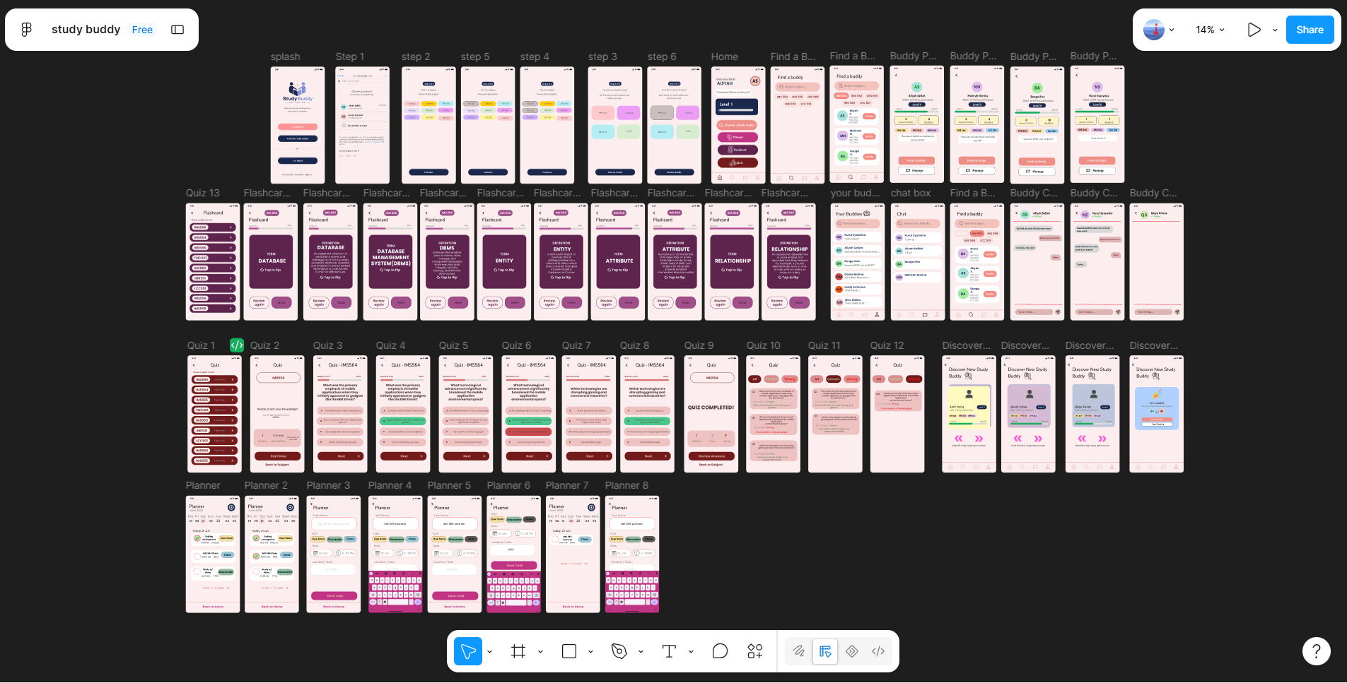
2.5 Testing
3.0 Functional Specification

